13.53: a) With 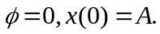

b) 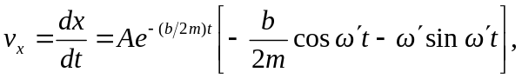
and at

c) 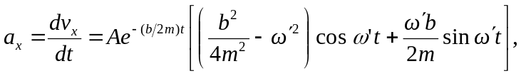
and at 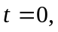
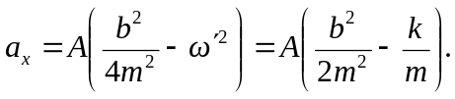
(Note that this is 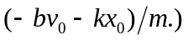 This will be negative if The graph in the three cases will be curved down, not curved, or curved up, respectively.

